TITLE
LOAD CONTROL SYSTEM USING DTMF

ABSTRACT:
A Bluetooth load control system[1] provides several advantages but the risks it posses have to be taken into account along with its good features while deploying and using this system can help them produce real benefits.
How a Bluetooth load control system can impact residential, commercial and industrial applications. They have been tracked affecting species in a variety of ways.
- Positive Impacts
Energy Saving, Convenience and Comfort with High level of Security, Flexibility: a Good Solution for Small Systems or Large Buildings Green benefits
- Negative Impacts
At the end of this I can also add on some details about -Initial Costs- Reliability and Interference-Security Concerns-Complexity-dependence on Technology.

Here are some keywords related to the topic of a load control system using Bluetooth:
  - Load Control System
  - Bluetooth Technology
  - Energy Efficiency
  - Remote control
  - Home Automation
  - Wireless Communication
  - Smart Devices
  - Cost Savings
  - Energy Management
  - IoT (Internet of Things)
  - Environmental Benefits
  - Scalability
  - Convenience
  - Flexibility
  - Automation
  - Smart Home
  - Security Systems
  - Signal Interference
  - Device Integration
  - Operational Efficiency
  - Carbon Footprint Reduction
  - Initial Costs
  - System Reliability
  - User-Friendly Interface

  - Energy Monitoring

To increase the efficiency and stability of an intelligent grid, a load control system[2] was proposed that optimized energy consumption methods and reduced peak demand. It allows you to save energy costs and avoid the overloads when there are demands for power.

We calculate this in quasi-real-time by tracking the consumption of energy and adapting load distribution to predictive analytics. This ensures efficient energy allocation.

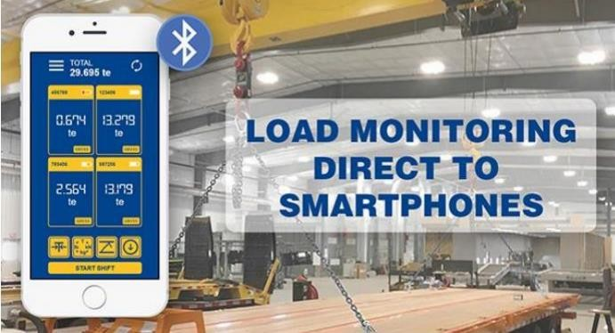

Fig 1.1 connecting of bluetooth

INTRODUCTION:
Using real-time data and predictive analytics, our load control system dynamically manages energy consumption by means of calibrated distribution of electrical loads in the project.
The system regulates powerloads to prevent overloading[2] and reduce peak demand, maintaining energy efficiency with the smart metering of real-time electricity usage data on a VPP app.
Load control systems[1] will benefit utilities, grid operators as well large energy consumers such industrial facilities and commercial buildings.
Our Load control systems ensure power grid stability, prevent blackouts and blackout prevention is a desperate need for the utility grids worldwide — down to lower energy cost and promote sustainable use of electric Power by making sure that demand/supply should always in balance.

Because load control systems reduce peak demand on the power grid, their implementation can have a big effect in terms of energy savings and environmental impact.

Our problem statement is manage and regulate the power consumption of a system or device to ensure efficient and safe operations.
The uses of our project is preventing overloading , optimal energy consumption, improve system stability and enhance safety.
It is also cost efficient , simple operations and remote control[4].

PROPOSEED METHOLOGY:
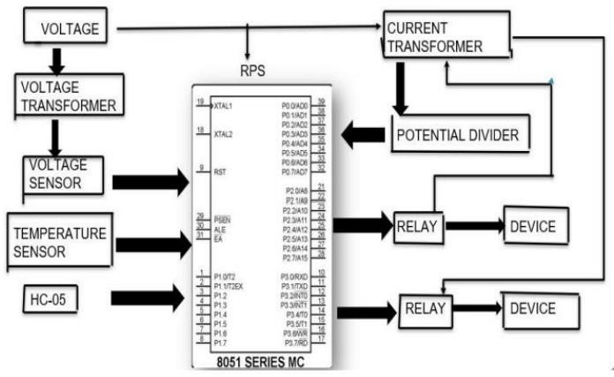
Fig 2.1 block diagarm
The methodology of a load control and monitoring system through Bluetooth[3] involves several steps.

First, a Bluetooth wireless load [5] cell (load-cell sensor) is designed and manufactured to measure the load. The load cell is then connected to a system that can convert the load into digital data, which can be numerically confirmed by a pressure sensor.

Next, a system is constructed to generate notifications and warnings step by step when the load is close to a dangerous load.

The system also confirms the load distribution pattern by position and establishes a method to confirm real-time data numerically and graphically.
Our project is remotely controlled [5]and flexible, efficiency, safely and described parameters.
Our project contains of relays which is used for controlling the switches.
Voltage sensors whish is used for monitor the voltage level.
And a current sensor which is used to measure the current flow. A microcontroller that anlyze the sensor data and compares it to pre- programmed thresholds ie. The limit.
Lastly the temperature sensor which monitors the temperature of various components.

The performance of the system is then verified through 3D finite element analysis by modeling and experimental tests.
Finally, the practical application of the load-monitoring system is evaluated using field-test data with a wireless load-cell.

RESULTS AND DISCUSSIONS:
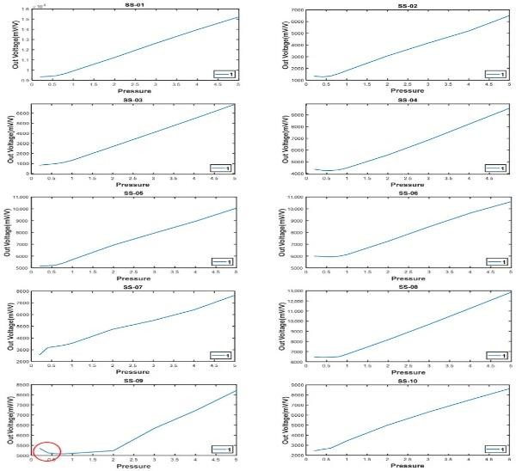
Fig3.1 loads control
The graph is about the maintenance.
A load control system[6] helps prolong the effective charge of a solar battery by controlling non- essential and heavy loads, allowing you to prioritize essential devices during a grid outage. This means your solar battery can access all your circuits, giving you whole-home backup. The system sheds loads to prevent the battery from
becoming overloaded, and you can decide which loads are most important before your home loses power.
With a load control system[5], you can control your non-essential and heaviest loads, such as pool pumps, exterior lights, and HVAC systems, turning them on and off as needed. This allows you to conserve energy and extend the duration of your battery.

For example, a simulation in Arizona showed that a load control system can make the storage capacity of a battery last more than twice as long. This technology is a key component of a whole-home[7] energy management solution, enabling your home to work smarter, not harder.

Overall, a load control system helps you stay comfortable at home during a grid outage, while also providing energy cost savings over time. It's a crucial tool in
managing household energy usage, especially during peak demand periods.
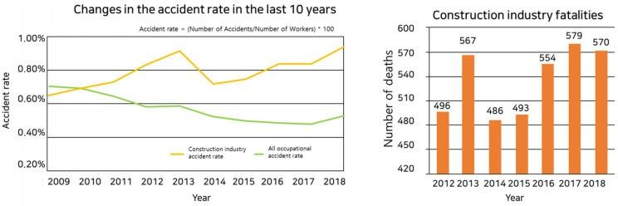
Fig3.2 over load accident
This graph is about the over loads cases

CONCLUSION:
Focuses on current control , voltage control ,overall power management and it specifically used for grid level. It also manages power consumption.
In recent years, the dependence on remote control over electrical appliances has increased, by
depending on various technologies, such as GSM, DTMF[8], Wi-Fi, IoT, and others. The remote control[4] is an excellent way to control electrical appliances such as water pumps, lamps, TV, cooling devices, heating appliances , and so on.
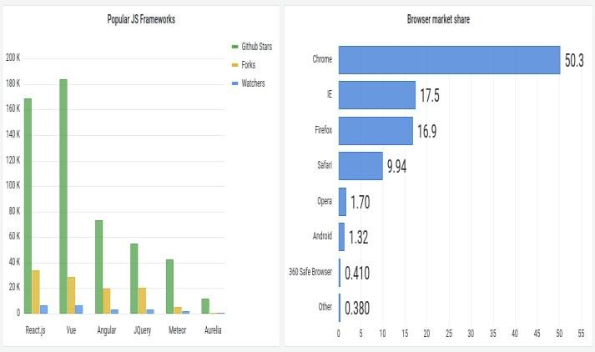 Fig 4.1 results of loads control

The accuracy and results of our project.

REFERENCES

[1].Gellings, C.W. (1985). "The Concept of
Demand-Side Management for Electric
Utilities." Proceedings of the IEEE, 73(10),
1468-1470.
- This paper discusses the fundamentals of
demand-side management, including load
control strategies, and their benefits for electric utilities.
[2]. Pipattanasomporn, M., Feroze, H., & Rahman,
S. (2009). "Multi-agent systems in a distributed
smart grid: Design and implementation." IEEE
Power Systems Conference and Exposition.
- Focuses on the implementation of multi-agent
systems in smart grids for distributed load control
and management
[3].Palensky, P., & Dietrich, D. (2011). "Demand
Side Management: Demand Response, Intelligent
Energy Systems, and Smart Loads." IEEE
Transactions on Industrial Informatics, 7(3), 381-388.
- Reviews various demand-side management techniques
, including load control, and their applications in
smart grids.
[4]. Venayagamoorthy, G.K., Ahmadi, A., & Harley,
R.G. (2010). "Dual Heuristic Programming for
Adaptive Control of a Grid-Connected
Photovoltaic System." IEEE Transactions on
Industry Applications, 46(5), 2025-2034.
- Explores adaptive control strategies for
integrating renewable energy sources with load
control systems.

[5]. Siano, P. (2014). "Demand response and smart grids—A survey." Renewable and Sustainable Energy Reviews, 30, 461-478.
- Provides a comprehensive survey on demand response and its role in smart grids, highlighting load control mechanisms.
[6]. Mohsenian-Rad, A.H., Wong, V.W.S., Jatskevich, J., Schober, R., & Leon-Garcia, A. (2010). "Autonomous Demand-Side Management Based on Game-Theoretic Energy Consumption Scheduling for the Future Smart Grid." IEEE Transactions on Smart Grid, 1(3), 320-331.
- Discusses autonomous demand-side management using game theory, including load control strategies.
[7]. Zhu, H., & Tang, J. (2013). "Demand Side Management in Smart Grids Using Load Control and Forecasting." IEEE Transactions on Smart Grid, 4(4), 1880-1888.
- Examines load control and forecasting techniques for effective demand-side management in smart grids.
[8]. Al-Ali, A.R., Zualkernan, I.A., & Rashid, M. (2011). "A smart home energy management system using IoT and big data analytics approach." IEEE Transactions on Consumer Electronics, 57(4), 1703-1711.
- Investigates the use of IoT and big data analytics in smart home energy management systems, including load control.

These references provide a solid foundation for understanding various aspects of load control systems, their implementation, and their
role in modern energy management. You can access
these papers through academic databases such as
IEEE Xplore, ScienceDirect, or Google Scholar.

